**INDUS EXAMS**

**A Project Report**

**Submitted by:**

**SIMRAN CHANDANI (IU1983830006)**

**in partial fulfillment for the award of the degree**

**of**

**Dual Degree (B. Sc. (CA & IT) + M. Sc. IT)**

**Semester V**

**at**



**Indus Institute of Information & Communication Technology**

**INDUS UNIVERSITY**

**November, 2021**

**Acknowledgement**

I have taken efforts in this project. However, it would not have been possible without the kind support and help of many individuals. I would like to extend my sincere thanks to all of them. I am highly indebted to Prof. Kirtan Kumar Rathod Sir for their guidance and constant supervision as well as for providing necessary information regarding the project & also for their support in completing of the project. My thanks and appreciations also go to my classmates for helping in the errors and people who have willingly helped me out with their abilities.

**Thank You**



**CERTIFICATE**

This is to certify that the project titled “INDUS EXAMS” is the bonafide work carried out by Simran Chandani, a student of Integrated MSc (CA & IT) during the academic year 2021-22, in partial fulfillment of the requirements for the award of the degree of Integrated Master of Science (CA & IT) semester V.

|  |  |
| --- | --- |
| **Internal Guide Signature:** | **Head of Dept. Signature:** |
| **Date:** | **Date:** |

**Table of Contents**

|  |  |  |
| --- | --- | --- |
| **Sr. No.** | **Contents** | **Page No.** |
|  | Introduction | 5 |
|  | Existing system | 6 |
|  | Problem areas of existing system | 7 |
|  | Need of system | 8 |
|  | Scope of system | 10 |
|  | Proposed System | 11 |
|  | Modules | 14 |
|  | Tools & Technology | 16 |
|  | System Flow Diagram | 17 |
|  | UML Diagrams | 19-26 |
|  | Data Dictionary | 27-31 |
|  | User Interface Screens | 32-61 |
|  | Test Plan and Test Cases | 62 |
|  | Future Enhancement | 63 |
|  | Conclusion | 64 |
|  | References / Bibliography | 65 |

**Introduction**

The Indus Exams is a web-based application. The system suits the need of Educational Institutions, Primary and Secondary Schools, Colleges, Professional and Vocational Institutes, Universities or Training Academies.

The product (system) aims at reducing costs associated with conducting exams over a period of time and achieving total automation of examination system-related tasks like registration, publication of results, which leads to a very high degree of system efficiency.

The project mainly intends to provide the insight of the functionality and behavior of the Online Examination System. This project integrates computer and Internet technologies for the purpose of student assessment. It provides the options of the examinations available on the system according to the student privilege.

This system is divided in three different sets : Student , teacher and Admin which work differently

**Existing System**

The traditional way of taking exam is pen and paper mode on the examination center. it takes a lot of time for every individual. The workload of teacher/faculty is also more like to set the question paper take the prints out make sure every student has perfect seats. On the other hand, student also has to compulsory visit the examination center.

**Problem areas of existing system**

As per the increasing no. of student the center has to face a lot of difficulties. On the other hand, due to covid also student can’t go to certain place to give examination. Existing system also takes a lot of time and money. Logistic and examination cost is very high. Result checking also takes few days. So, its better to turn digital.

**Need of new system**

The traditional examination system has been in place for a long time. Over the years, tweaks in exam duration, question format, evaluation methods, and feedback have evolved, but generally speaking this pen and paper model has persisted over decades of education. So why the change to an online examination system now?

Simply put, with innovations in technology, an increasingly globalized world, and data-driven insights into teaching and learning methodologies, an online examination system might provide a better perspective into the scholarly journey of a student. Examinations are not just a part and parcel of student life. They are an evaluative tool that allows students, teachers, and parents to track and measure the student’s scholarly progress. It also serves as a concrete metric on which to base learning and teaching decisions for the future.

Unlike a traditional examination system, an **INDUS EXAMS** is more enhanced in numerous ways. From easier setup to remote access, to faster evaluations, an online exam system is better at fulfilling its primary role of being an evaluative tool.

The workload on various resources/teachers automatically gets minimal because the entire test creating, conducting and evaluating methods get automated.

Students don’t have to come to a specific place which is the case with paper-based tests. Online tests are not restricted with geographical boundaries and students can attempt tests from any part of the world.

**Features of this system**

* Security of question paper
* Quick result processing
* Get rid of examination centers
* Save time
* Reduce logistics cost
* Question paper generation
* Reduce examination cost
* Flexibility of exam management

**Scope of System**

The traditional approach to measuring a person’s level of knowledge in topic has been examination. These days there is often more emphasis on internal assessment, which may consist of assignment and project given out by the teacher and marked or assessed by the same teacher.

It is a modern method of conducting examination widely accepted and hastily increasing environment of conducting examination through online in all the sectors of education and job. It will considerably replace the traditional paper and pen based exam in future. In present days the availability of the computers and the wide spread nature of the internet has laid a strong foundation path for conducting most of the prestigious exams on-line

Online examinations have become more than just a trend in India. The exponential rise in online learning has made online exams a valuable resource for educational institutions and corporates.

In India , as we all know that from last 1.5 year the whole country has mostly turn online because of the exponential rise of covid-19 . No one could go out for there normal work also so for the student it was next to impossible to give exams offline like regular.

Because of that the country has to do all the things online mode and till now also the situation is not normal like before people are scared to let the child go out for study. So, this system will help the organization to conduct the exam online mode so that each student could take part and continue their future study.

**Proposed system**

Indus Exams is efficiently used in day-to-day life because it saves time and also it is most accurate system as maximum participants are increasing in today’s life. Online examinations are available with instruction and guidelines so that students can understand properly. It is necessary for every technical student to have basic knowledge of online examination system. All the entrance exams are held online because of its fast and accurate marking scheme. Online examination is more flexible than written examination. It is basically design to promote the variation in education system. Due to online examination, there is less chance of losing integrity of exam pattern. For e.g., it is least possible for disposing the online examination setup when compared with other examination system.

**FUNCTIONS OF ONLINE EXAMINATION SYSTEM**

Examination Management: The task of this examination management is questioning, appending, removing and updating the questions.

Origination of paper: The task of originating the paper randomly to acquire its particular need. It is the basic purpose of online examination system. Here the structure of paper was placed by score and number of questions which delegate a paper. There are many types of questions for example like multiple choices, true or false etc. The structure of paper can be freely set by user according to its needs. After selecting the structure of paper, the further steps of paper generating and outputting takes place.

Online Analysis: This is used by students to check online test by selecting a paper randomly or use of paper assigned by teacher or within the network of campus and also by understanding the instructing levels.

**LITERATURE ANALYSIS**

The entire process of allocating test and analyzing their scores after the test was operated manually for example examining test and distributing score which used to take a lot of time when online examination was not in existence. To take written exam of number of students we need more invigilators to watch examination candidates for the purpose of reducing or preventing cheating.

It is developed for reducing large number of relevant resources. Indus Exams is developed base on web and network. It recognizes the concept of design system that characterizes the main purpose of the system, examining the algorithm of creating question paper and also about the security of the system. The method of online examination was for important activities like to evaluate performance of student in existing institutes. The exam question quality of online examination will regulate or decide the quality of students growing in the institutes. Present technologies as familiar with advanced techniques like adding question bank in database. It also helps to originate or generate the different questions in sets without repeating and reducing the duplication of questions. Online Examination System characterize the use of shuffling algorithm is a Generator Question System (GQS) as one of the techniques used to overcome randomization issues of collecting sets of exam paper.

**ADVANTAGES OF INDUS EXAMS**

* Indus Exams is a computerized system which gives instant results and also saves time.
* It fully automates the previous manual process of taking written exams.
* It decreases the need of supervision during the exam is being examine or taken using web based Indus Exams gives a high level of clarity as opposite of traditional method. Most of Online Examination System gives the result and instantly
* In high school, Indus Exams is able to reduce the workload of teachers by using automated test paper exams and marking schemes.
* Students can study independently for example at home or any place.
* The amount of time given at a particular question gives you the ability of “Quick Learning Quick Thinking “.
* The data in Online Examination System is regenerated repeatedly so that students have access to new data.

**DISADVANTAGES OF ONLINE EXAMINATION SYSTEM**

* The question and answers may be tricky and confusing as there are multiple choices for answers.
* Lack of interaction between the teacher and student.
* Network problems may arise in Online Examination System, test may be postponed or cancel.
* As India is not a fully developed country problem may arise in rural areas where there is deficiency of computers or where computers are not yet discovered.
* Hackers can easily manage to achieve confidential data through fake online application or websites.
* While attempting online exams we can easily manage to open another window on existing computer.
* Teaching techniques of an instructor or teacher may vary from online exam questions

**Modules**

Here we have three Modules:

* Student: User mostly a student who will appear for exam
* Teacher: Another user is a faculty member, lecturer or examiner who will set the questions, available options and correct answer
* Admin: Super user, manage teacher and student section

Student

Based on the choice of the student, the system provides the questions related to that area. Mostly the questions are in the form of multiple-choice question, they can also be filling in the blanks, matching and essay questions. At the end of the questions, the student will get the marks.

When a person enters the online exam, a system will ask for login id and password. If the person is authorized, by simply giving his login id and password he will enter filling the registration field based on the privilege. If the student is new, he/she has to register as a student by filling the registration details. While filling the details he/she has to take care on privilege.

If the student is registered, as soon as he submits the login id, he/she enters in to the area section. There he/she can select the area depending on which he wants to take the exam. As soon as he selects the area, he will be ready to take the exam

Depending upon the area selected, questions the be displayed with four options and the student has to select the correct answer and proceed to the next question till the end of the exam. As soon as the user complete the exam the marks will be automatically generated.

 Teacher

Here, the Faculty member, lecturer or examiner can set the question with the four different options available for the student and the correct option. There is also an option to give the marks per question so that the system automatically generates the marks report at the end of examination.

When a teacher enters to the system will ask filling the registration field based on the privilege. If the teacher is new, he/she has to register as a teacher by filling the registration details. While after filling the registration details the teacher has to wait for the approval of the admin.

After that he/she can login with password and use the system as a teacher. Teacher can set the subject and then add the multiple choices questions(mcqs) based on the particular subject with the available options and the correct one too.

Admin

Now we have the admin panel with all the rights, super user. It has the basic functionality of login and password generated as superuser in Django.

Admin panel has a teacher section, a student section, manage subjects, manage question. So, we can say that admin has the full advantage. In teacher section, he/she can approve or delete a teacher profile. In student section, he/she can view student profile and view the marks too. He/She can manage the subjects and the questions.

**Tools & Technology**

**Development Tool** - Visual studio code

**Web Server** - Local Host

**Front End** - HTML, CSS

**Back End** - Python, Django

**Documentation tool** – MS word

**Drawing Tool** – draw.io

**System Flow Diagram**

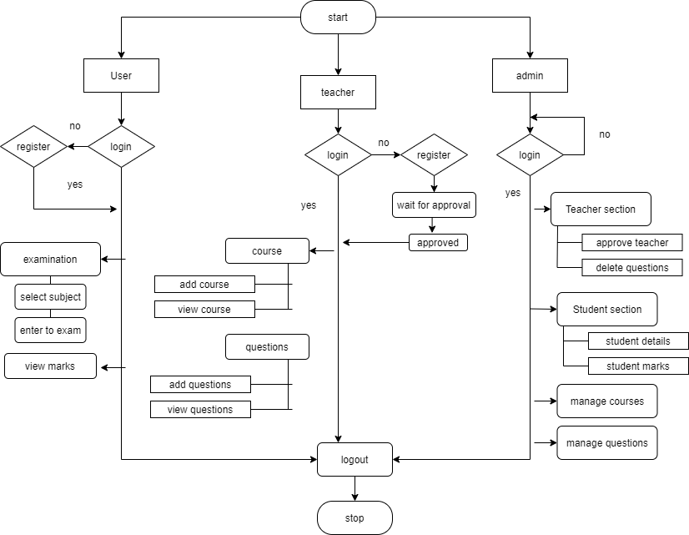

A**system flow diagram**shows the path taken by the system and the decisions made during different levels. Different symbols are strung together to show system flow, including what happens to system and where it goes.

System flow diagrams are helpful for showing system pathways for programming processes, but they can also be used for multiple other processes. One of the primary uses of system flowcharts is in the management processes. Processes like inventory management and supply chain management require assistance from such flowcharts to understand the movement of goods from one point to another.

Here in our System flow diagram we have seen the 3 different models. One is User (student) , Second is our Teacher who conduct the examinations , Third one is admin in which all the management process occurs.

This system here shows us the flow of our system like student has to first login if not then must register first then login. After that a student can move ahead and give the examinations and view the marks at the end generated by the system. In teacher panel same login and register system and then a teacher can move ahead select the subject and arrange a set of question paper with four different options. In admin panel, the whole management occur and a admin can manage student, teacher, subjects and questions too.

**Use case Diagram**

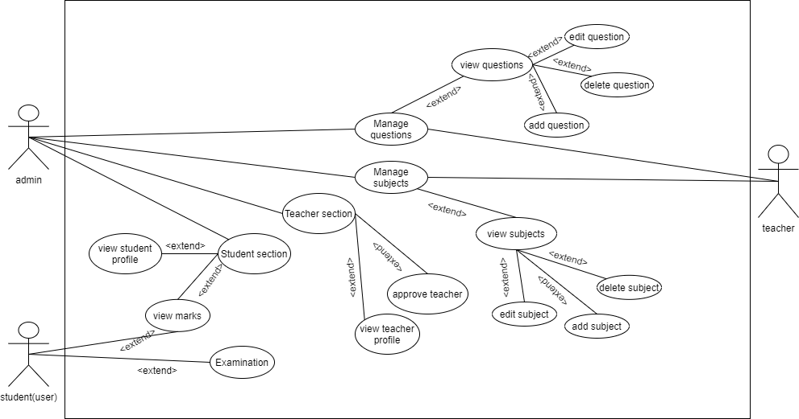

Use case diagrams are typically developed in the early stage of development and people often apply use case modelling for the following purposes:

* Specify the context of a system
* Capture the requirements of a system
* Validate a systems architecture
* Drive implementation and generate test cases
* Developed by analysts together with domain experts

In this use case diagram, we have 3 actors: student, teacher and admin which connect each other at some functions.

**Activity Diagram (User)**

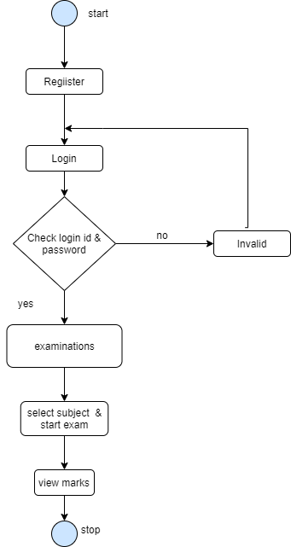

Activity diagram is another important diagram in UML to describe the dynamic aspects of the system.

Activity diagram is basically a flowchart to represent the flow from one activity to another activity. The activity can be described as an operation of the system.

The control flow is drawn from one operation to another. This flow can be sequential, branched, or concurrent. Activity diagrams deal with all type of flow control by using different elements such as fork, join, etc.

Here the first activity diagram that we have is the system related to User or we can say that about student. As the system start Student need to login if not that first register themselves and then start their login process. System will check if the credentials are correct or not if not then you have to enter the correct credentials.

Student has options like examinations and view marks. In examination he/she should select the subject and go ahead to give examination. And after the examination done your marks will be stored in the system.

**Activity Diagram (Teacher)**

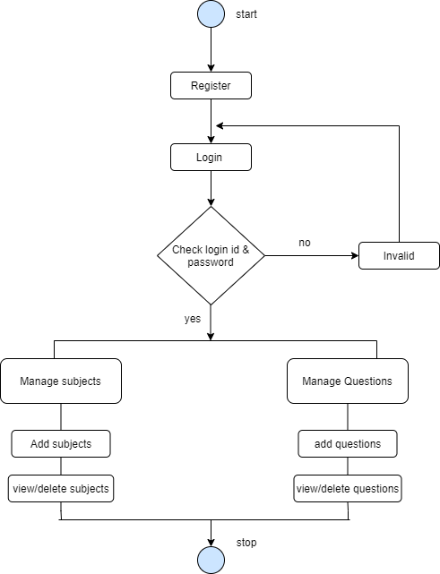

The basic purposes of activity diagrams is similar to other four diagrams. It captures the dynamic behaviour of the system. Other four diagrams are used to show the message flow from one object to another but activity diagram is used to show message flow from one activity to another.

Activity is a particular operation of the system. Activity diagrams are not only used for visualizing the dynamic nature of a system

Here in teacher module, a teacher can manage the subjects like he/she can add subjects and can remove or view any subject.

They can add the questions according to there examination process with the specific marks so that it would be easy for calculation at the end. Questions are of multiple choice with four different options. They can add, view or delete a question too**.**

**Activity Diagram (Admin)**

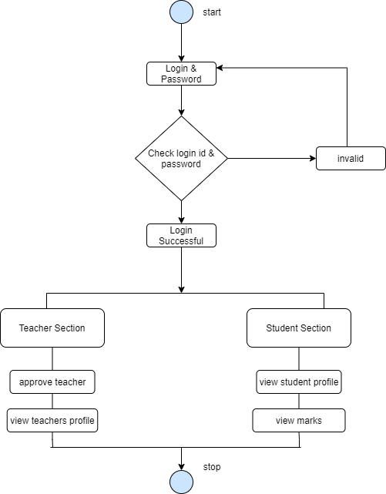

Activity diagrams are mainly used as a flowchart that consists of activities performed by the system. Activity diagrams are not exactly flowcharts as they have some additional capabilities. These additional capabilities include branching, parallel flow, swim lane, etc.

Here in Activity diagram for admin, after start of flow we have to check the login credentials which admin has input. After which if its incorrect they have to try again or if its correct they can start their work.

Admin has the right to manage each and every thing of the system like to manage student section to check/update students’ profile or to view their marks too. In teachers section admin has to approve teacher and then can check/update teacher profile too

**DATA DICTIONARY**

**Registration**

|  |  |  |  |
| --- | --- | --- | --- |
| Fields | Data-type | size | Constraints |
| First Name | Varchar | 10 | Not null |
| Last Name | Varchar | 15 | Not null |
| Contact | Integer | 10 | Not null |
| Address | Varchar | 40 | Not null |
| Username | Varchar | 10 | Primary key |
| Password | Varchar | 15 | Primary key |

Here in Registration form, User have to give first name, last name, Contact, Address, Username & Password to register their details and can lagin further with Username & Password.

**Subject**

|  |  |  |  |
| --- | --- | --- | --- |
| Fields | Data-type | size | Constraints |
| Subject Name | Varchar | 50 | Foreign key |
| Total Questions | Integer | 3 | Not null |
| Total marks | Integer | 10 | Not null |

In Subject table, a teacher/faculty/examiner or admin can add the subject with specific no. of questions and the total marks.

**Questions**

|  |  |  |  |
| --- | --- | --- | --- |
| Fields | Data-type | size | Constraints |
| Subject Name | Varchar | 50 | Foreign key |
| Marks | Integer | 10 | Foreign key |
| questions | Varchar | 600 | Primary key |
| Option1 | Varchar | 200 | Not null |
| Option2 | Varchar | 200 | Not null |
| Option3 | Varchar | 200 | Not null |
| Option4 | Varchar | 200 | Not null |
| answer | Varchar | 200 | Not null |

In Question table, a teacher/faculty/examiner or admin can add the subject name, mark of the specific question, question, with four different options and the correct answer.

**Contact**

|  |  |  |  |
| --- | --- | --- | --- |
| Fields | Data-type | size | Constraints |
| Name | Varchar | 30 | Not null |
| Email | Varchar | 20 | Primary key |
| Message | Varchar | 500 | Not null |

In contact table, if the user is having any query or message, he/she can add in this form and then submit.

**Result**

|  |  |  |  |
| --- | --- | --- | --- |
| Fields | Data-type | size | Constraints |
| Subject Name | Varchar | 50 | Foreign key |
| Marks | Integer | 20 | Foreign key |
| Exam(attempts) | Varchar | 3 | Not null |
| Date | Integer | NA | NA |

In this, the user is shown the result with subject name, their marks, attempts and the date which include the date & time of the examination automatically.

**SCREENSHOTS**

**Student Panel**

* **Screenshot of Home page**

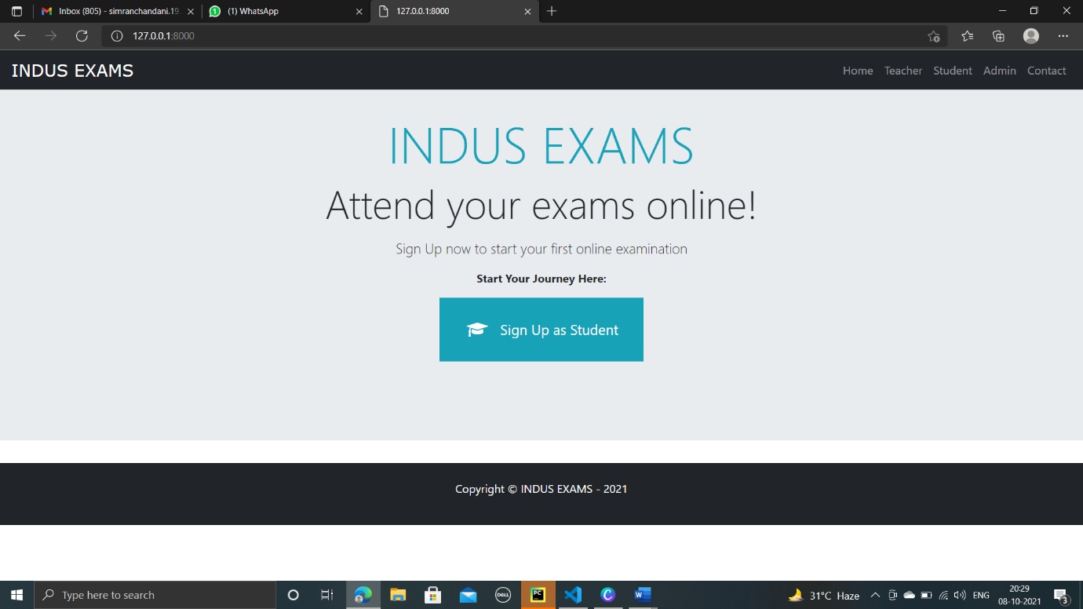

Home page as we enter to the web, we can see the navbar including student, teacher, admin panel and a contact option and a sign-up button for the student to register themselves

* **Screenshot of Student Signup form**

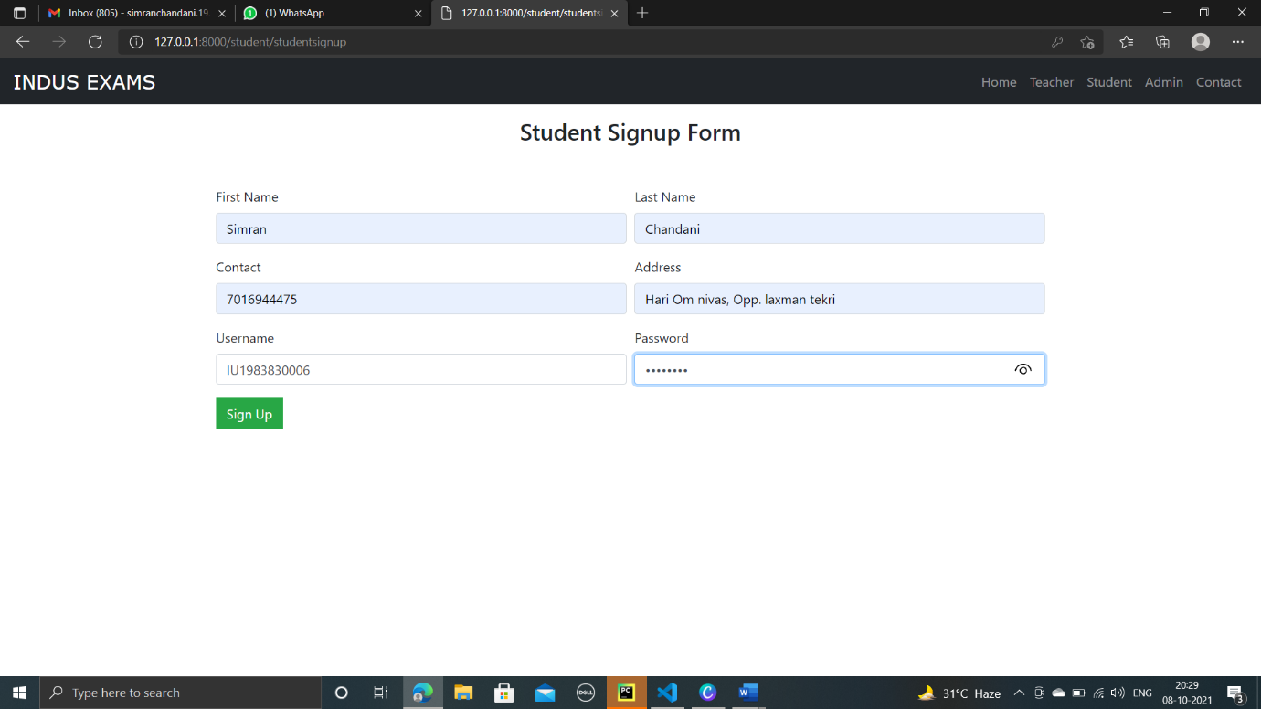

Registration page for student with first name, last name, contact address, username and password.

* **Screenshot of Student Login page**

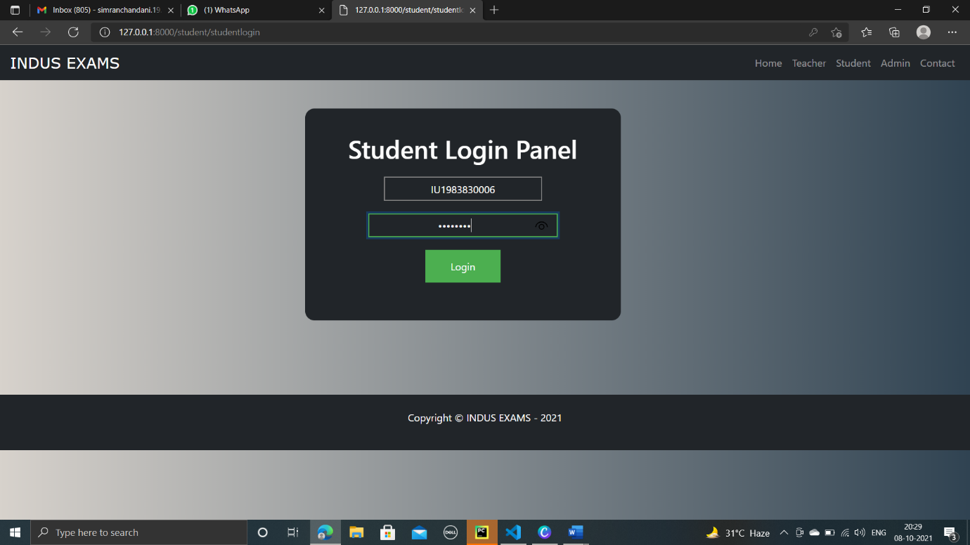

Student login page with username and password.

* **Screenshot of student Dashboard**

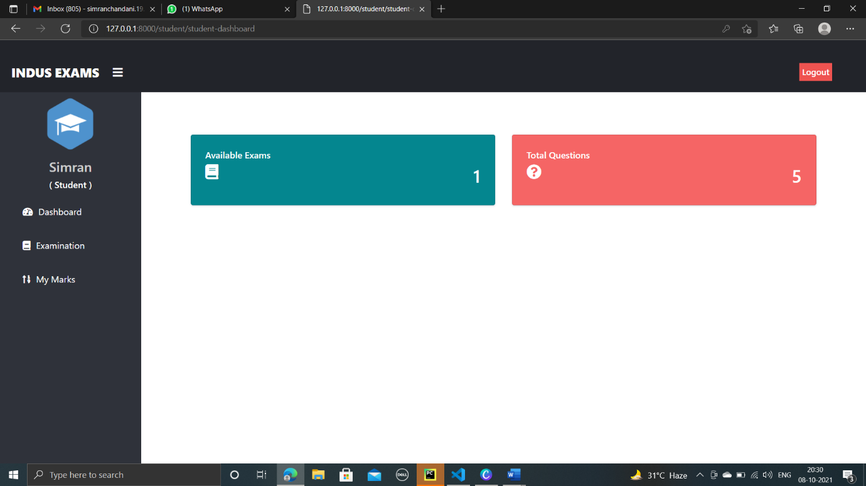

Student dashboard with the no. of exam available and total questions

* **Screenshot of Examination page**

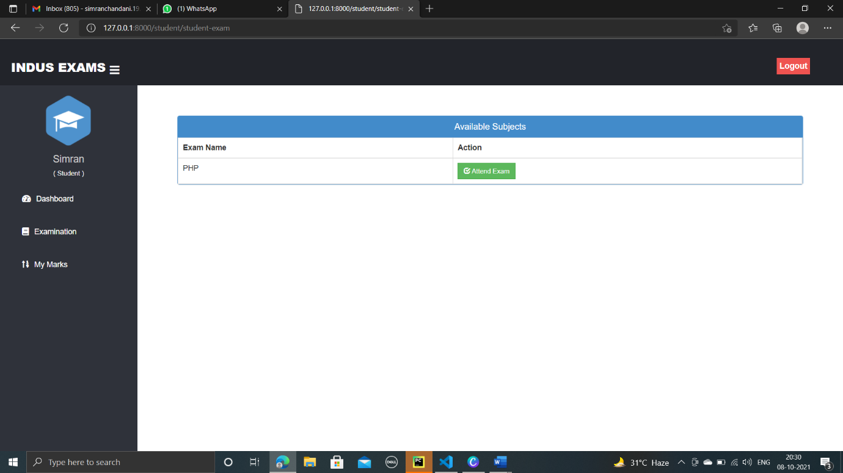

Examination page as we enter to exam with subject name to attend

* **Screenshot of Rules for examination page**

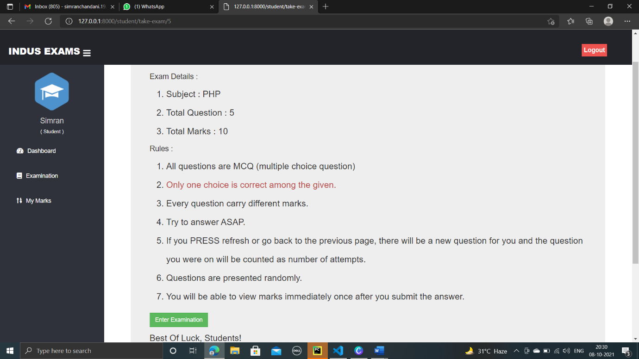

Rules for examination before student enter

* **Screenshot of Exam page**

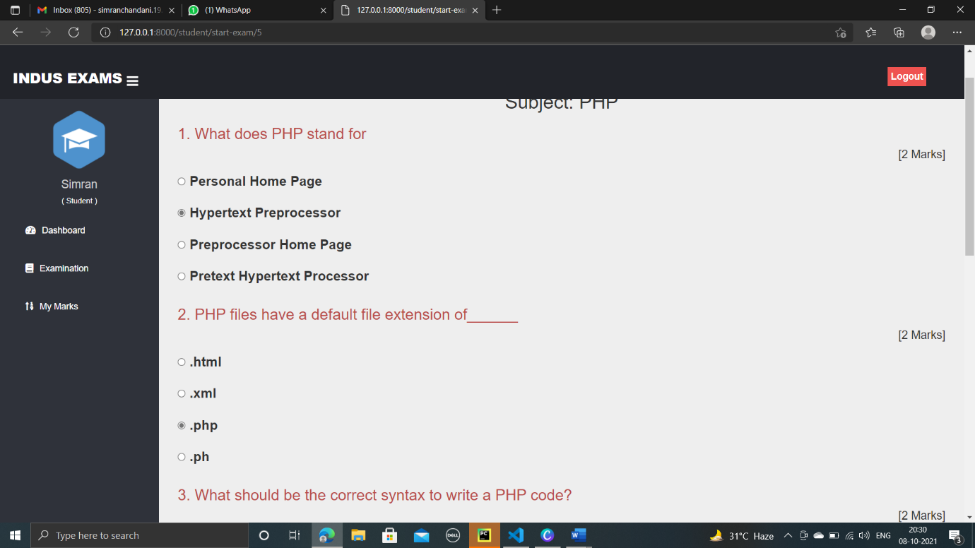

Examination begins

* **Screenshot for view of marks**

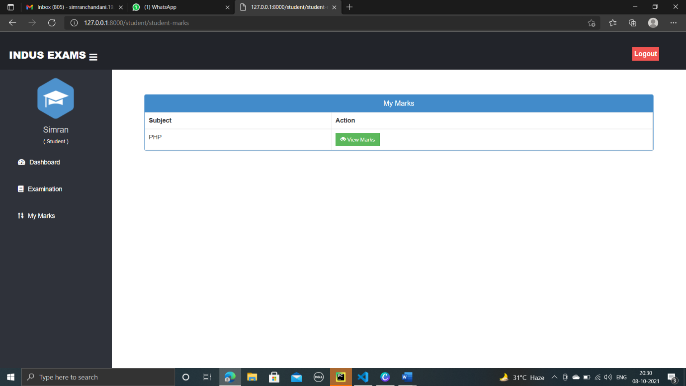

After the examination a student can view their marks as per subject

* **Screenshot of Marks**

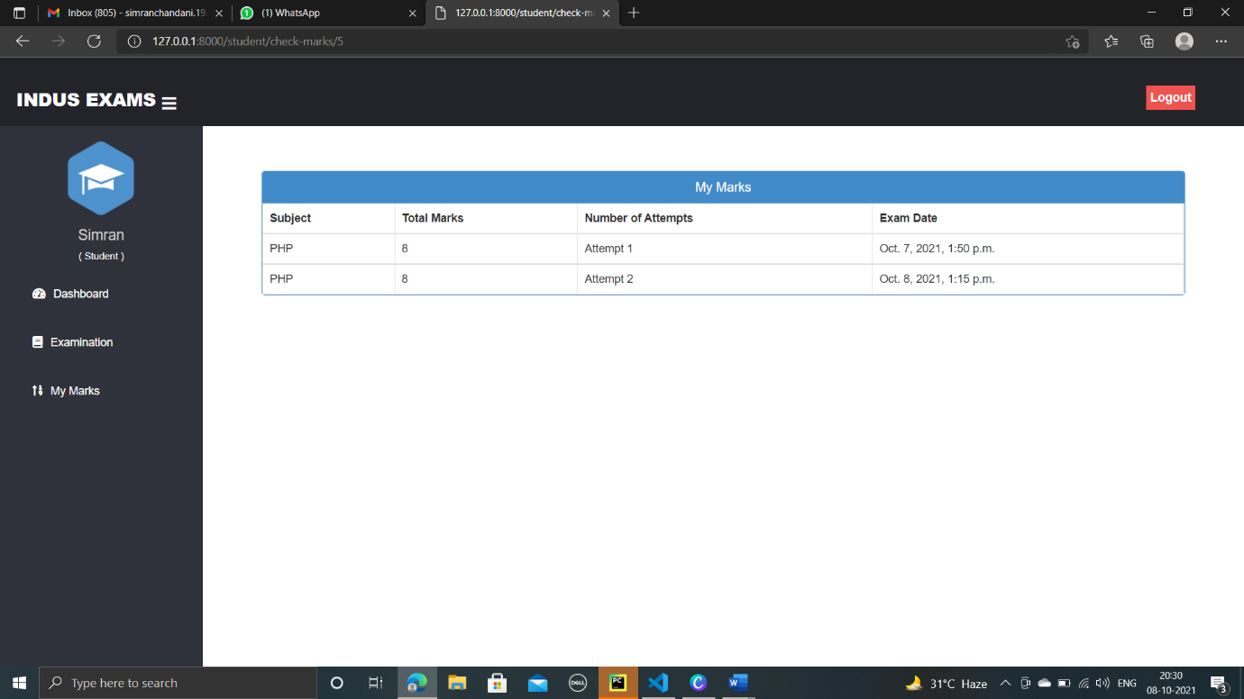

This screen shows the marks of student with the attempts and the date and time of exam

**Teacher panel**

* **Screenshot of Teacher Index page**

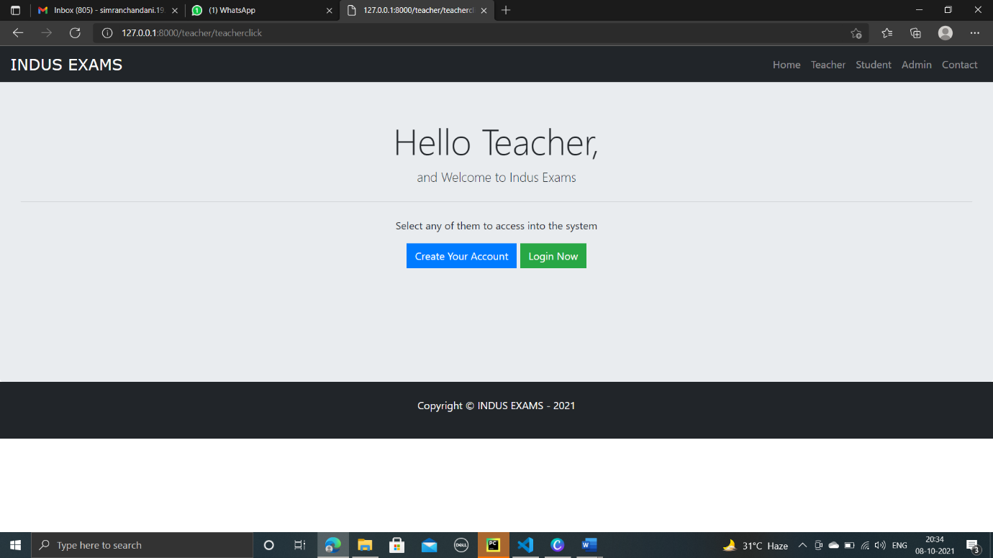

Teacher home page with registration and login option

* **Screenshot of Teacher Registration page**

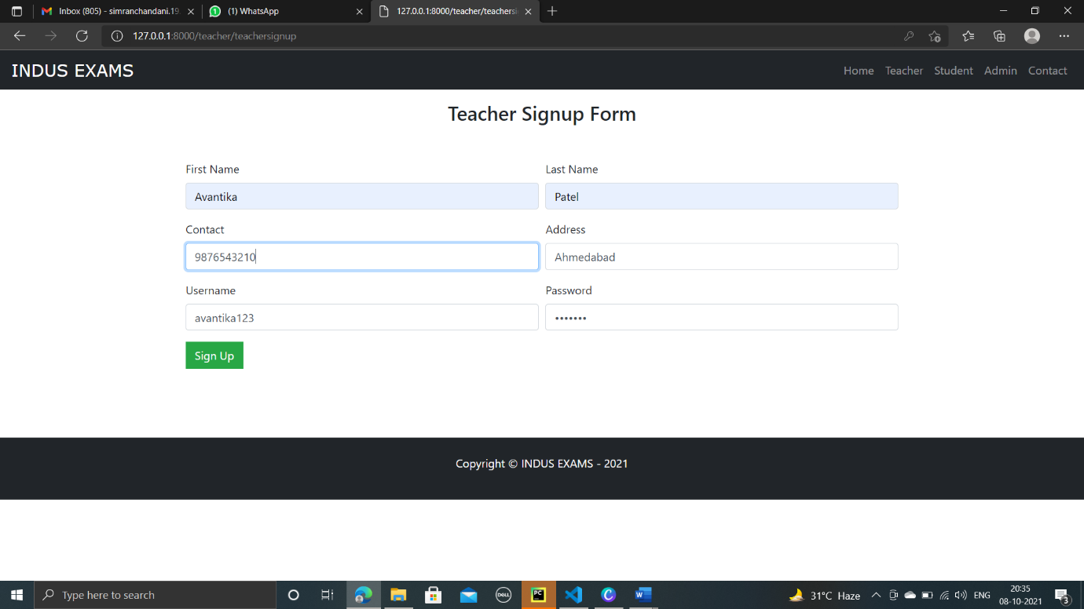

Registration page for teacher with first name, last name, contact address, username and password.

* **Screenshot of Teacher Login page**

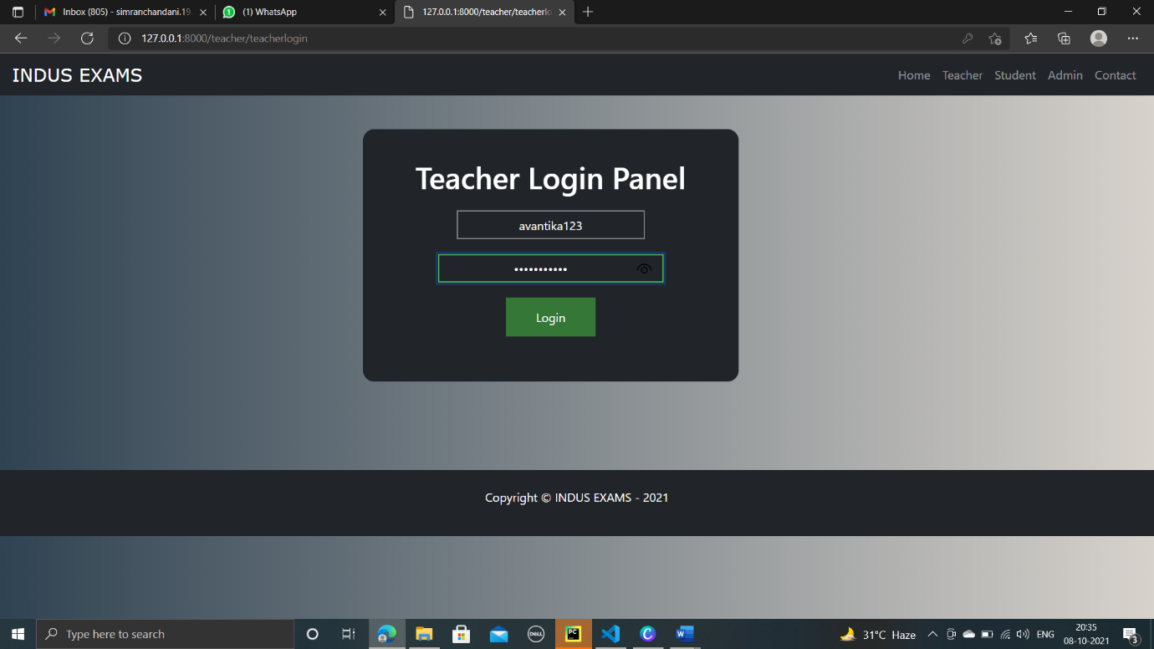

Login page for teacher with username and password

* **Screenshot of Teacher Dashboard**

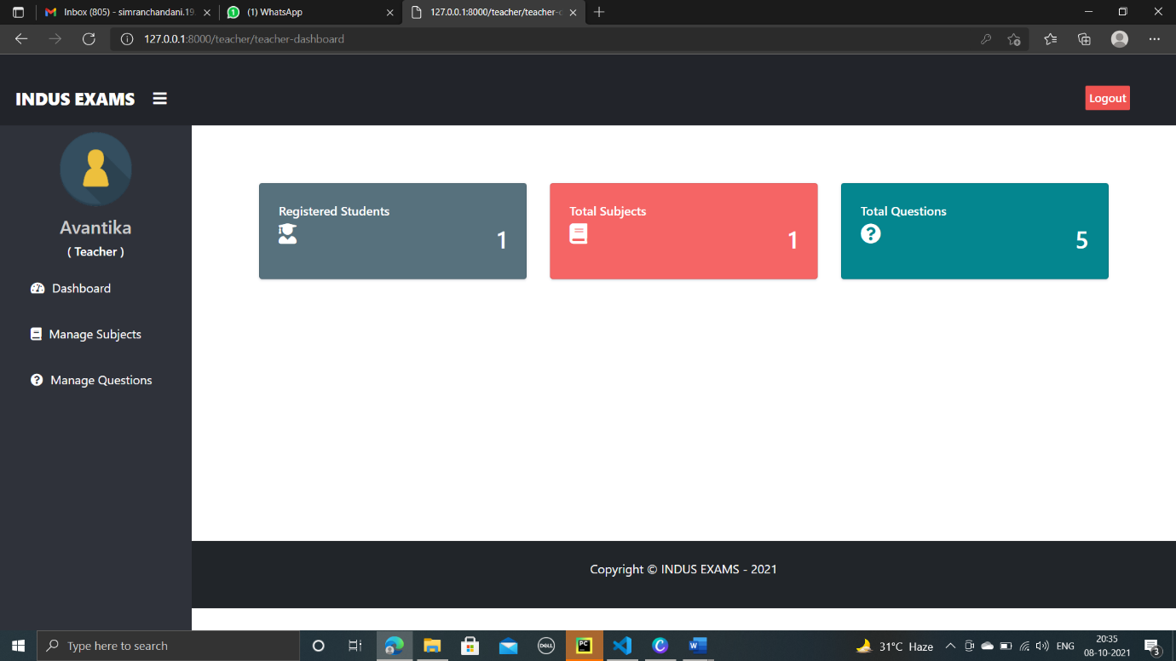

Dashboard with no. of student, total subjects and no. of questions available

* **Screenshot of Manage subject page**

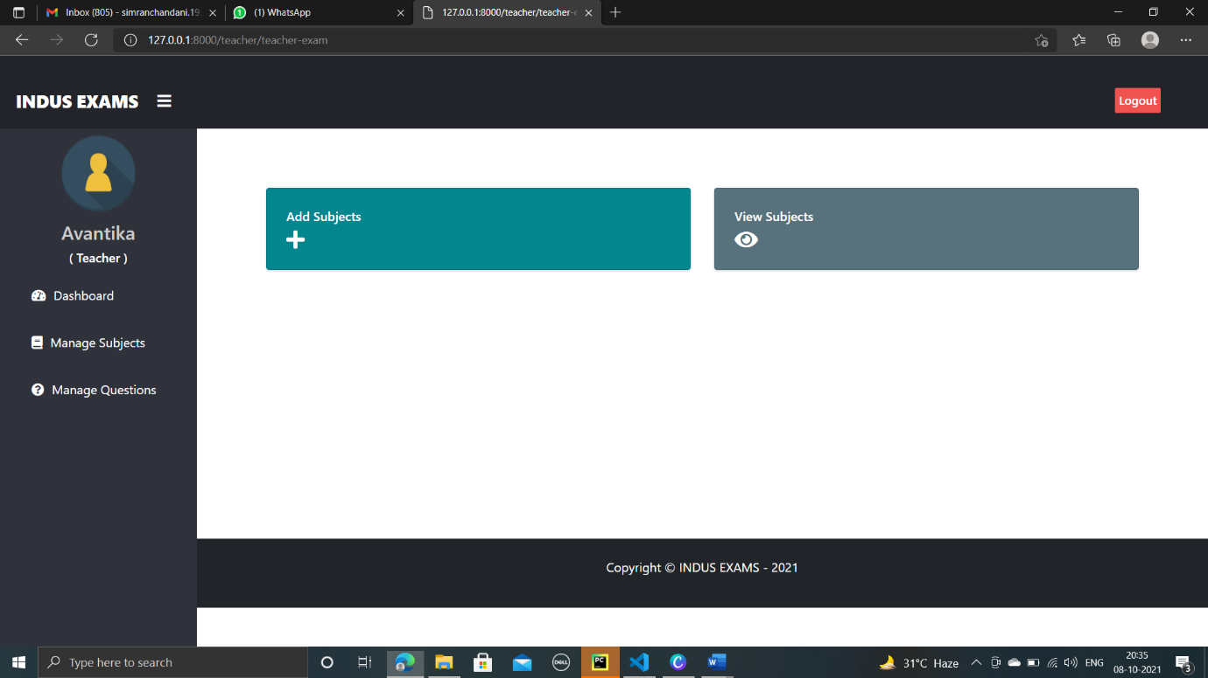

Manage subject with add subject or view subject

* **Screenshot of Add subject page**

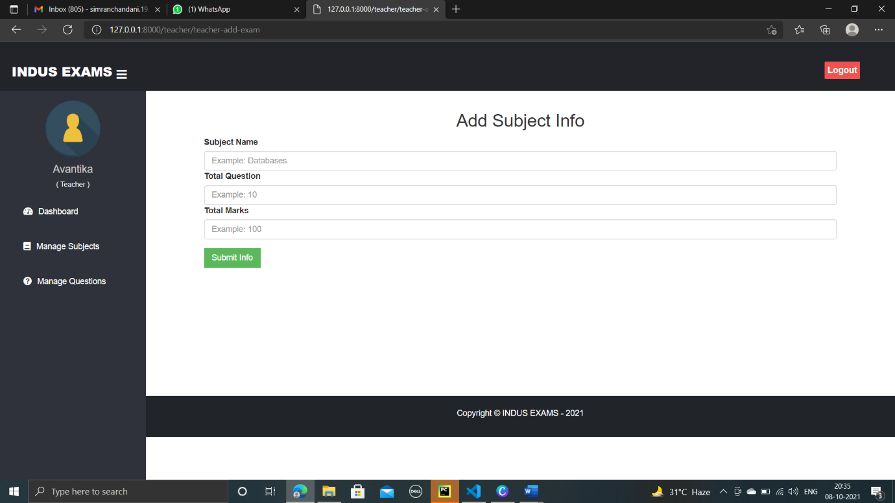

Add the subject with total no. of questions and marks

* **Screenshot of View/delete subject page**

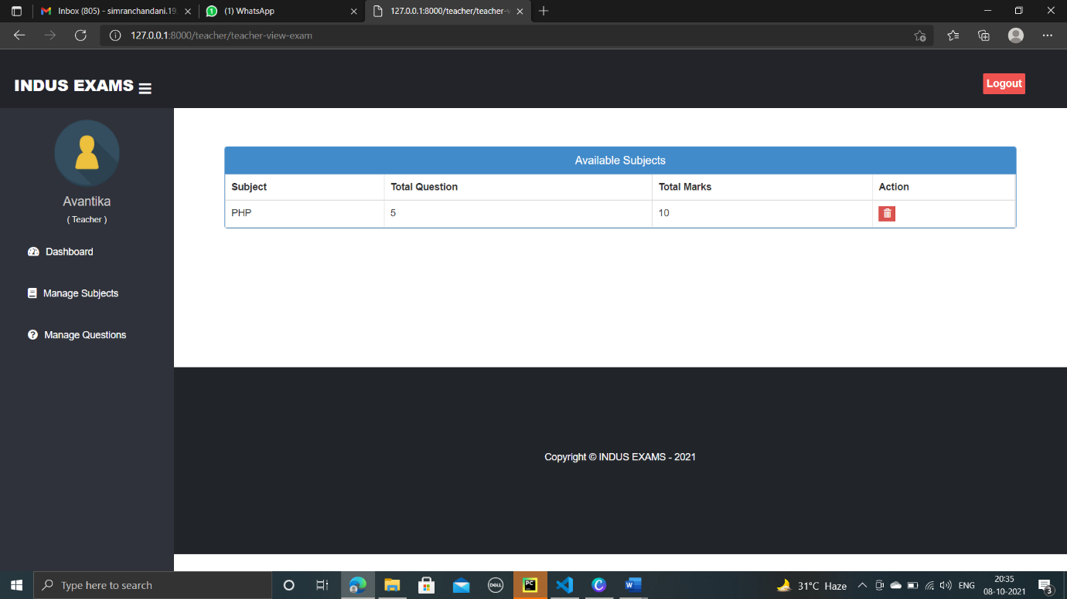

In this, we get to see the no. of subject with the particular no. of question and marks.

* **Screenshot of Add question page**

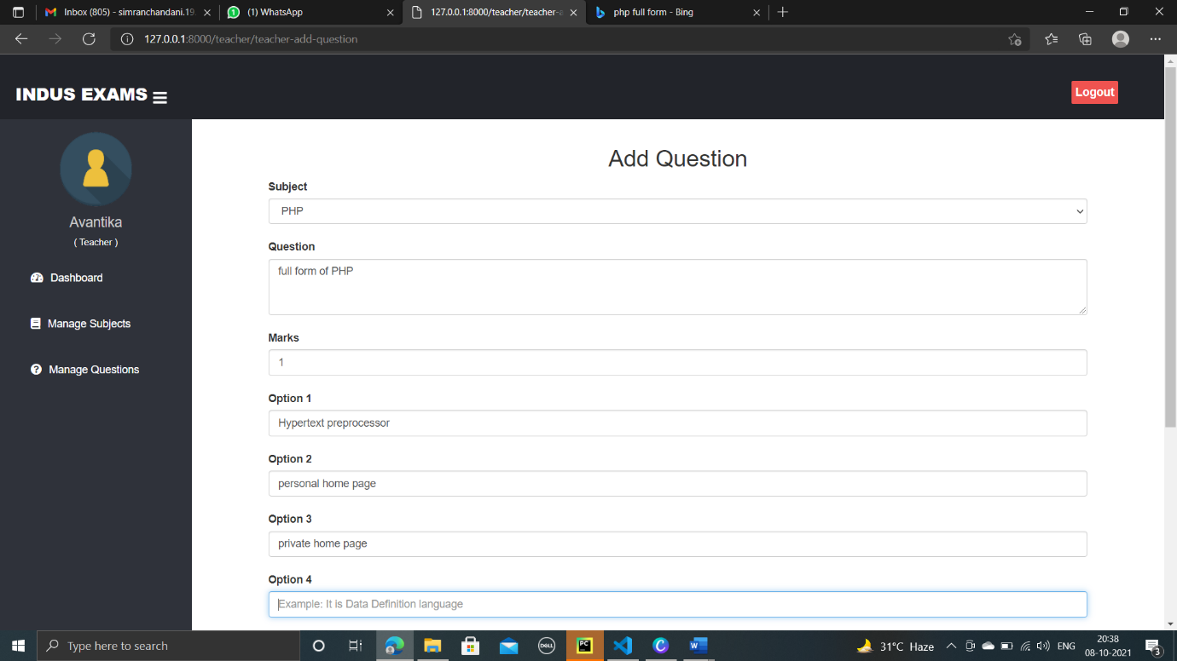

We can add questions to this page with the four different option and one correct answer.

* **Screenshot of view/delete questions**

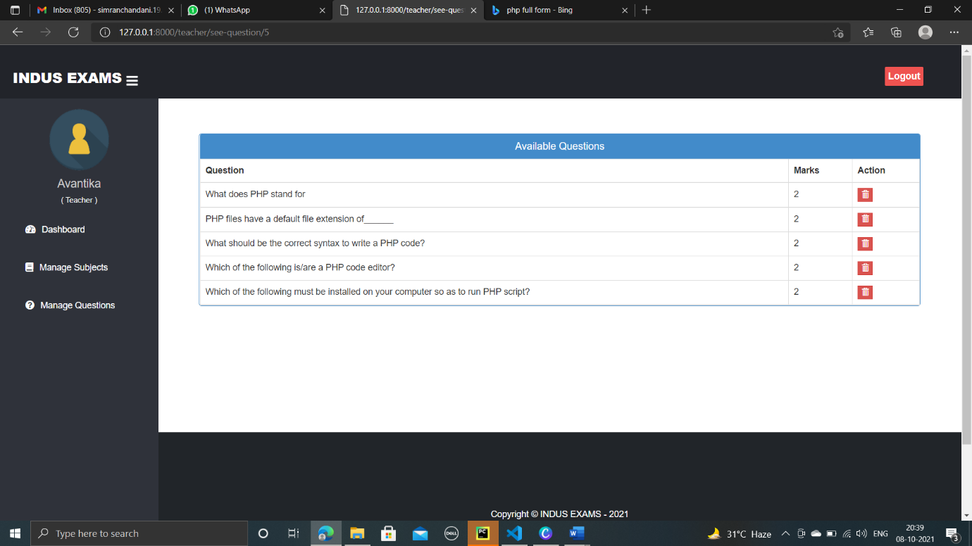

This shows us the questions and option to delete that question.

**Admin panel**

* **Screenshot of Admin login page**

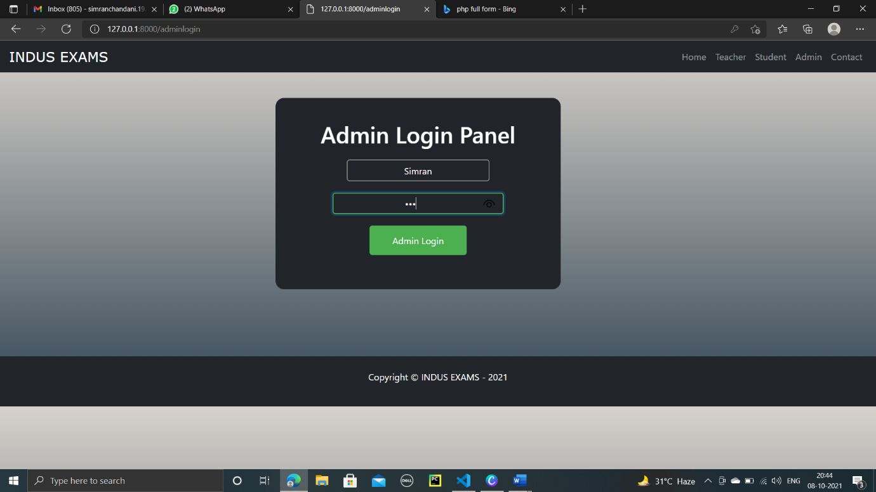

Admin login page with Username & password.

* **Screenshot of Admin dashboard**

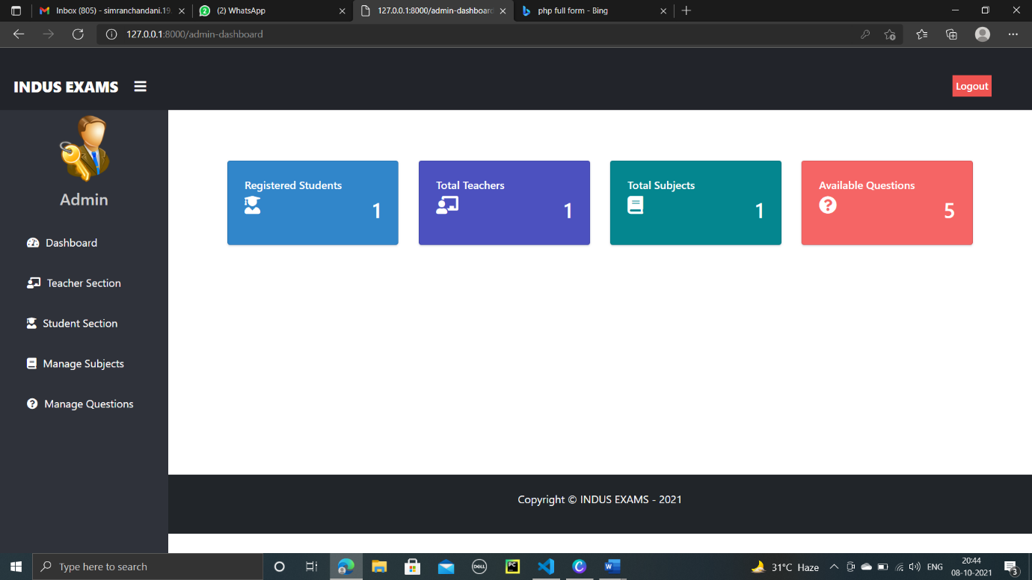

Admin dashboard has the information regarding the total no. of student, total no. of teachers, total no. of subject and total no. of questions available with the dashboard having the options of teachers and student section with manage subjects & questions.

* **Screenshot of Teacher Section**

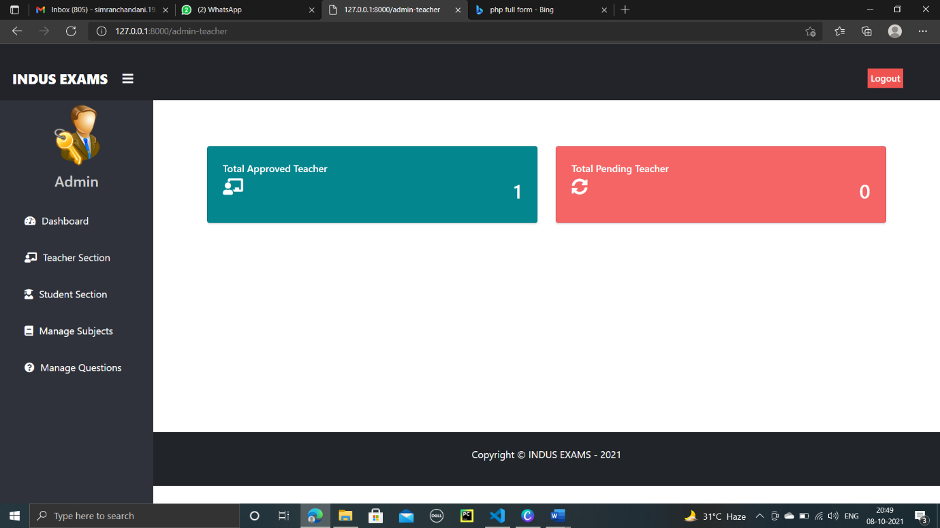

This provides the information about the Dashboard, no. of approved teacher and pending teacher with the logout option in navbar

* **Screenshot of View teacher profile**

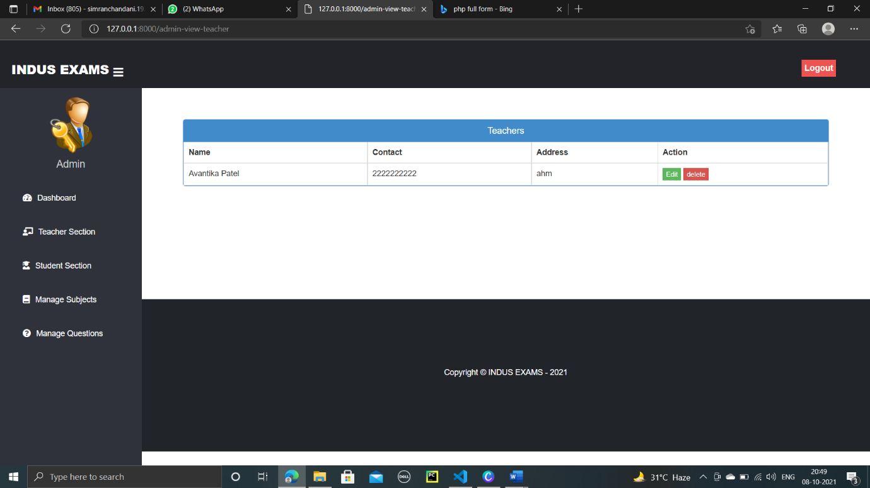

This gives admin the details of the teacher with name, contact, address and the option to edit and delete.

* **Screenshot of Update teacher profile**

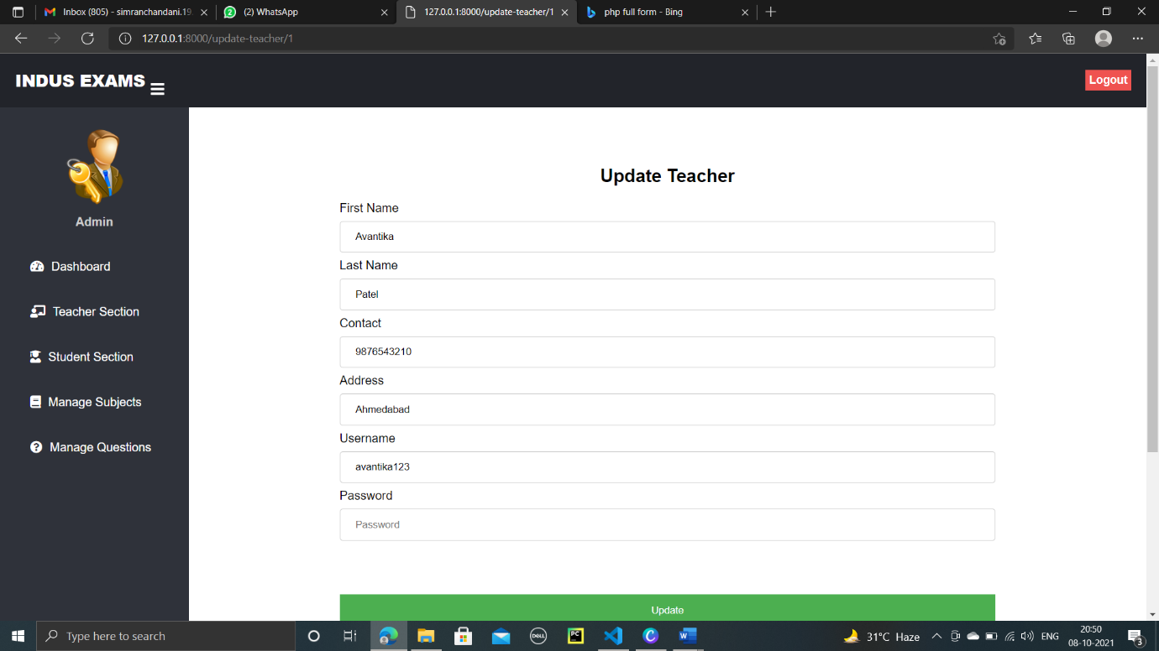

This page gives admin right to update any teachers profile.

* **Screenshot of Pending teacher approval**

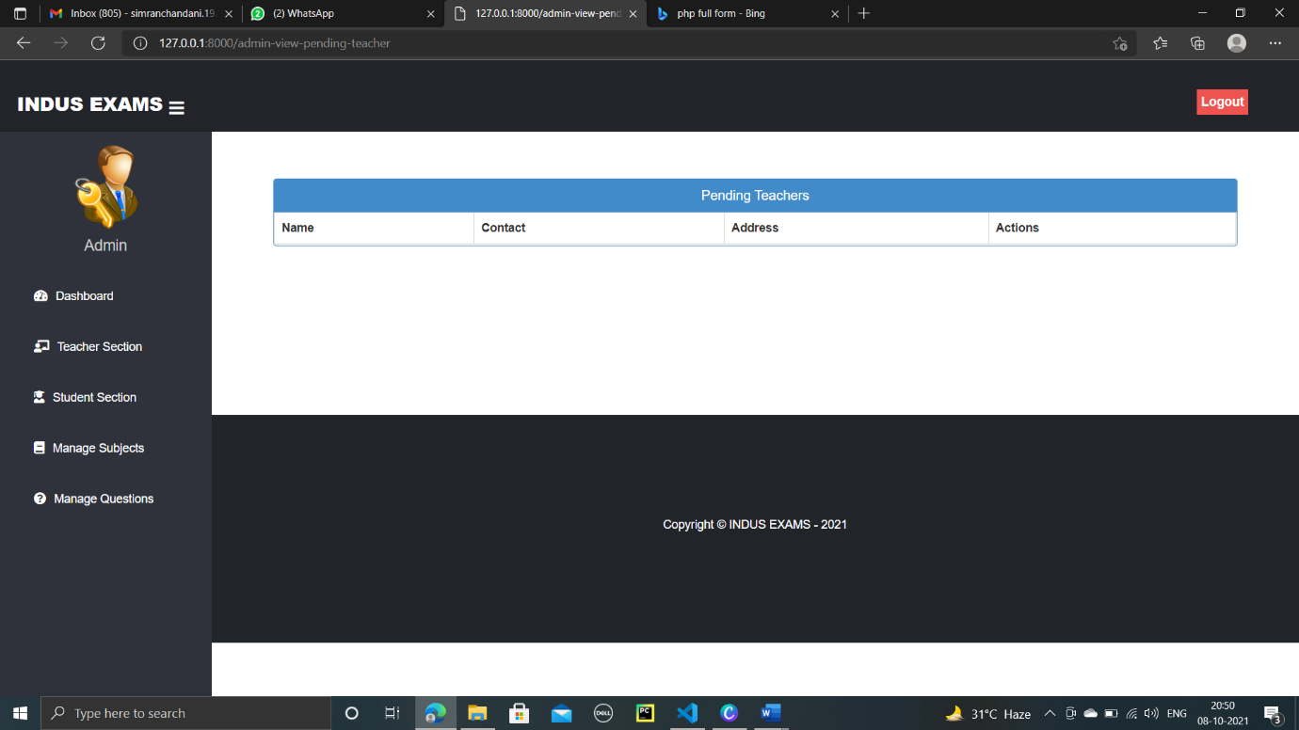

This shows the name, contact, address and action like approve or reject for the pending teacher

* **Screenshot of Student Section**

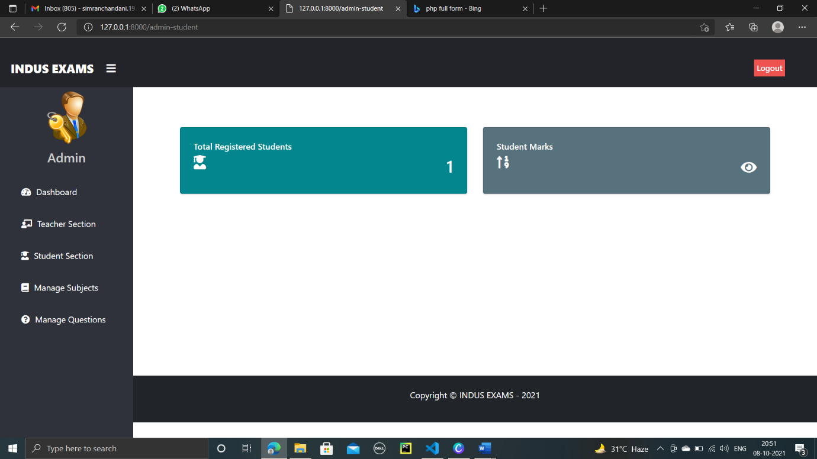

This provides information regarding the registered no. of student and to view their marks.

* **Screenshot of view/edit/delete student profile**

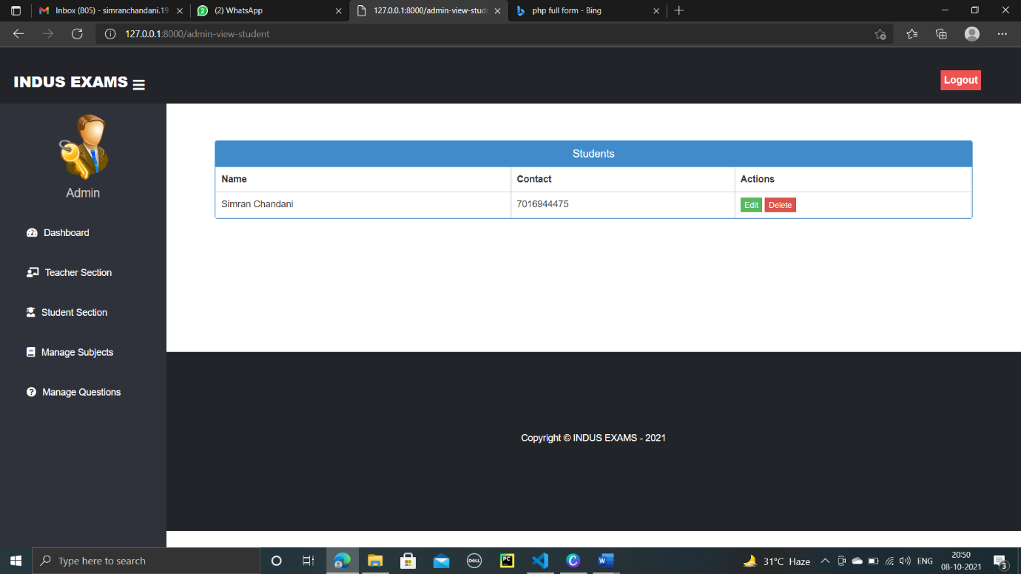

This shows the detail of particular student with their name , contact and the options like edit or delete the profile**.**

* **Screenshot of update student profile**

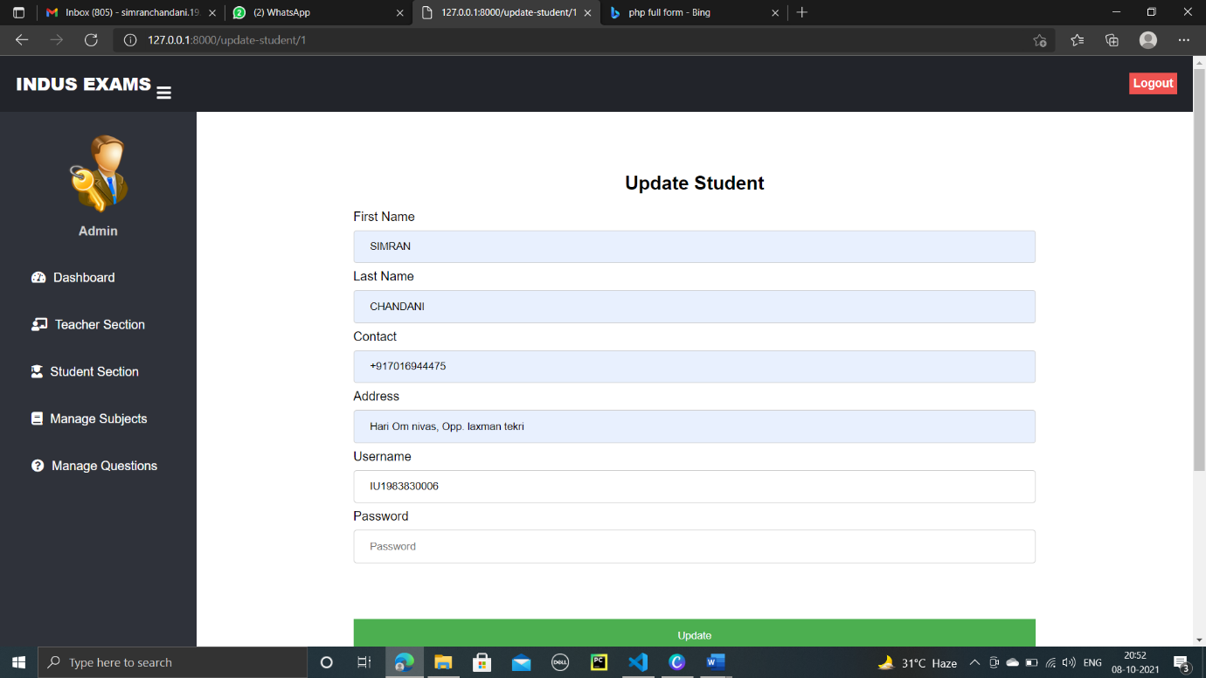

In this admin has the right to update the profile of any registered student.

* **Screenshot of view student marks**

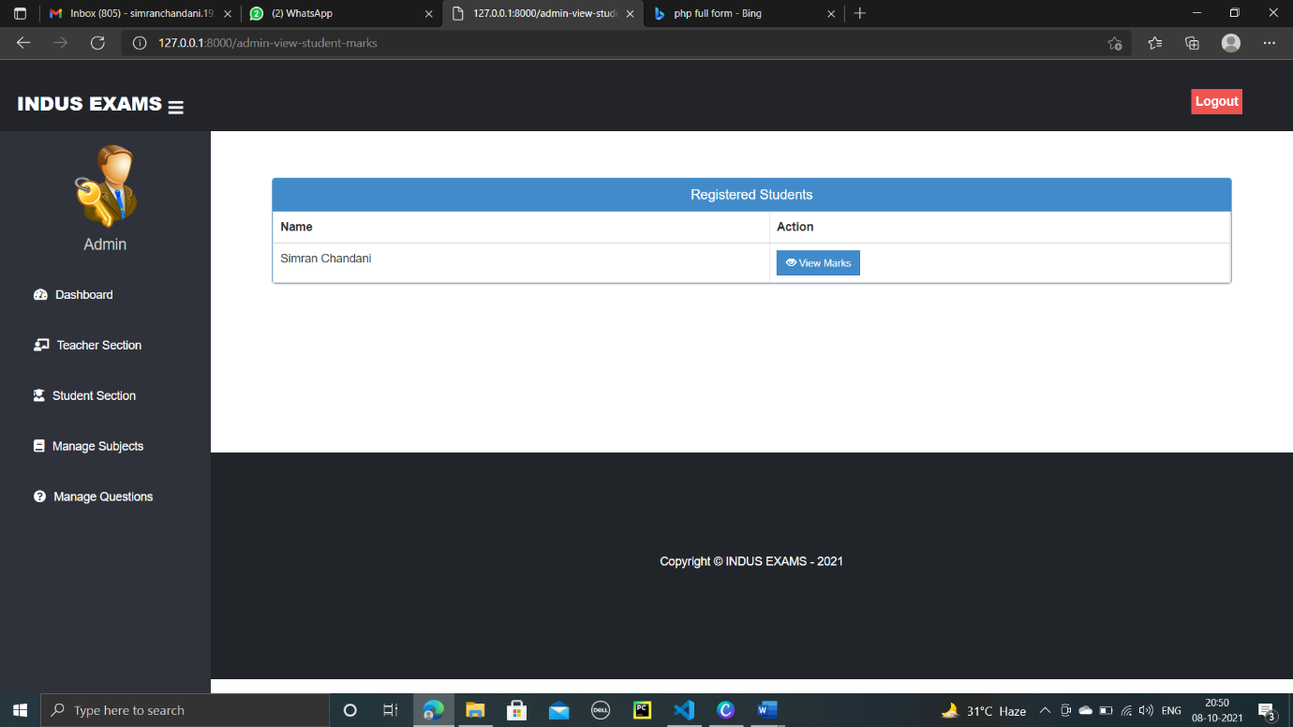

In this, there is an option to view marks of any student.

* **Screenshot of Logout page**

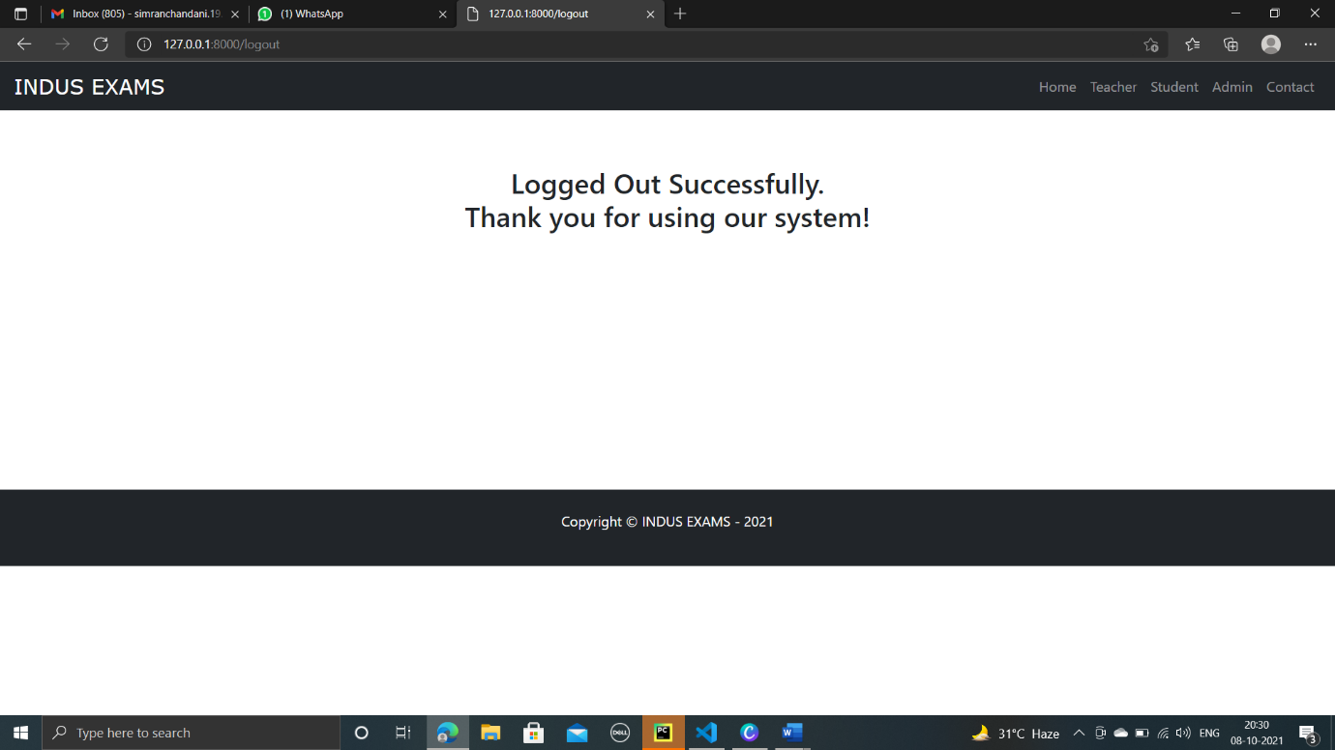

This page shows certain content after we logout.

* **Screenshot of Contact page**

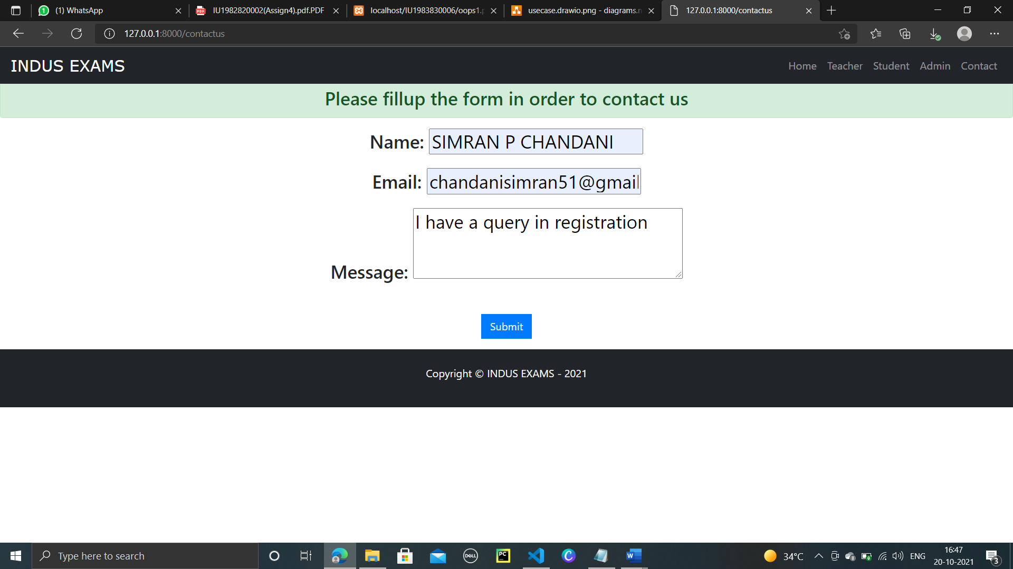

This page gives right to anyone having any query or message to admin.

**TEST PLANS & TEST CASES**

|  |  |  |  |  |  |
| --- | --- | --- | --- | --- | --- |
| **No.** | **Test case description** | **Test data** | **Expected result** | **Actual result** | **status** |
| 1. | Check response when teacher/admin add question | question | Added successfully | Added successfully | pass |
| 2. | Check response when teacher/admin add question with correct option | Correct Answer | Please enter the answer | Please fill out this field | Pass |
| 3. | If teacher login without the approval | login | Wait for approval | Wait for approval | pass |
| 4. | If teacher wants to delete question | Delete question | deleted | deleted | pass |
| 5. | If student doesn’t attend any question | result | 0 marks | 0 marks | pass |

**FUTURE WORK**

There are a lot of limitation too in our system like there is no option for the teacher can only manage one subject if admin doesn’t want to give right to some teacher , so as for the future work we would like to solve that and make Indus Exam the best Online Examination platform

**CONCULSION**

Indus Exam is a web application. The key concept is to minimize the paper work and convert all the forms and documentation in digital form. Also, with the current Covid situation we have seen almost everything turning digital so user is not physical pressure to come at a particular location to give exam. The User with minimum knowledge of computer can also easily operate the system.

**REFERENCE**

Django Documentation - <https://docs.djangoproject.com>

Stack overflow - <https://stackoverflow.com>

Search Engine - <https://www.google.co.in>

Bootstrap - <https://getbootstrap.com>

Draw.io - <https://drawio.bbva.com>